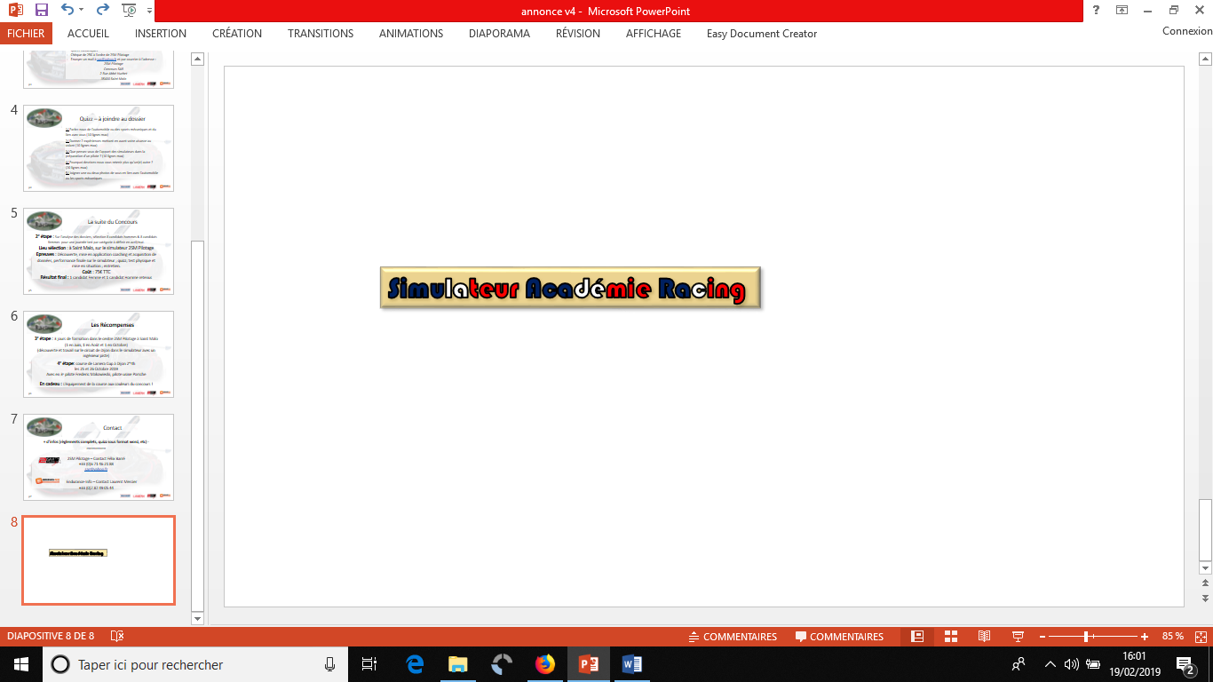
Questionnaire – Concours SAR 2020
1/ A quand remonte votre passion pour les sports mécaniques ?
Vous déplacez-vous sur des évènements sport mécanique ? (10 lignes max)
_________________________________________________________________________________________________________________________________________________________________________________________________________________________________________________________________________________________________________________________________________________________________________________________________________________________________________________________________________________________________________________________________________________________________________________________________________________________________________________________________________________________________________________________________________________________________________________________________________________________________________________________________________________________________________________________ .
3/ Que pensez-vous de l’apport des simulateurs dans la préparation d’un pilote ? (10 lignes max)
_________________________________________________________________________________________________________________________________________________________________________________________________________________________________________________________________________________________________________________________________________________________________________________________________________________________________________________________________________________________________________________________________________________________________________________________________________________________________________________________________________________________________________________________________________________________________________________________________________________________________________________________________________________________________________________________ .
4/ Pourquoi devrions-nous vous retenir plus qu’un(e) autre ? (20 lignes max)
___________________________________________________________________________________________________________________________________________________________________________________________________________________________________________________________________________________________________________________________________________________________________________________________________________________________________________________________________________________________________________________________________________________________________________________________________________________________________________________________________________________________________________________________________________________________________________________________________________________________________________________________________________________________________________________________________________________________________________________________________________________________________________________________________________________________________________________________________________________________________________________________________________________________________________________________________________________________________________________________________________________________________________________________________________________________________________________________________________________________________________________________________________________________________________________________________________________________________________________________________________________________________________________________________________________________________________________________________________________________________________________ .
5/ Joignez une ou deux photos de vous en lien avec l’automobile ou les sports mécaniques : (ci-dessous ou en pièces jointes)

Nom : Prénom : Sexe :
Numéro de téléphone :
Mail :
Adresse :







